Point
# Source: AI Source: Provided by: [Data Path: Persons Table -> ID Column: 1, Name_En Column: Motasem Essam] -> From: [ChatGPT] on [7/25/2026]
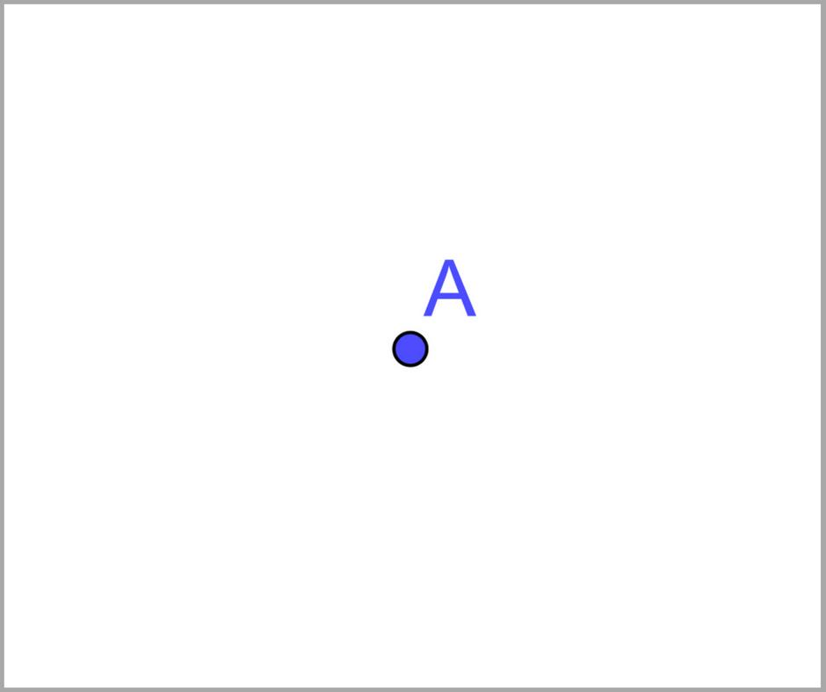
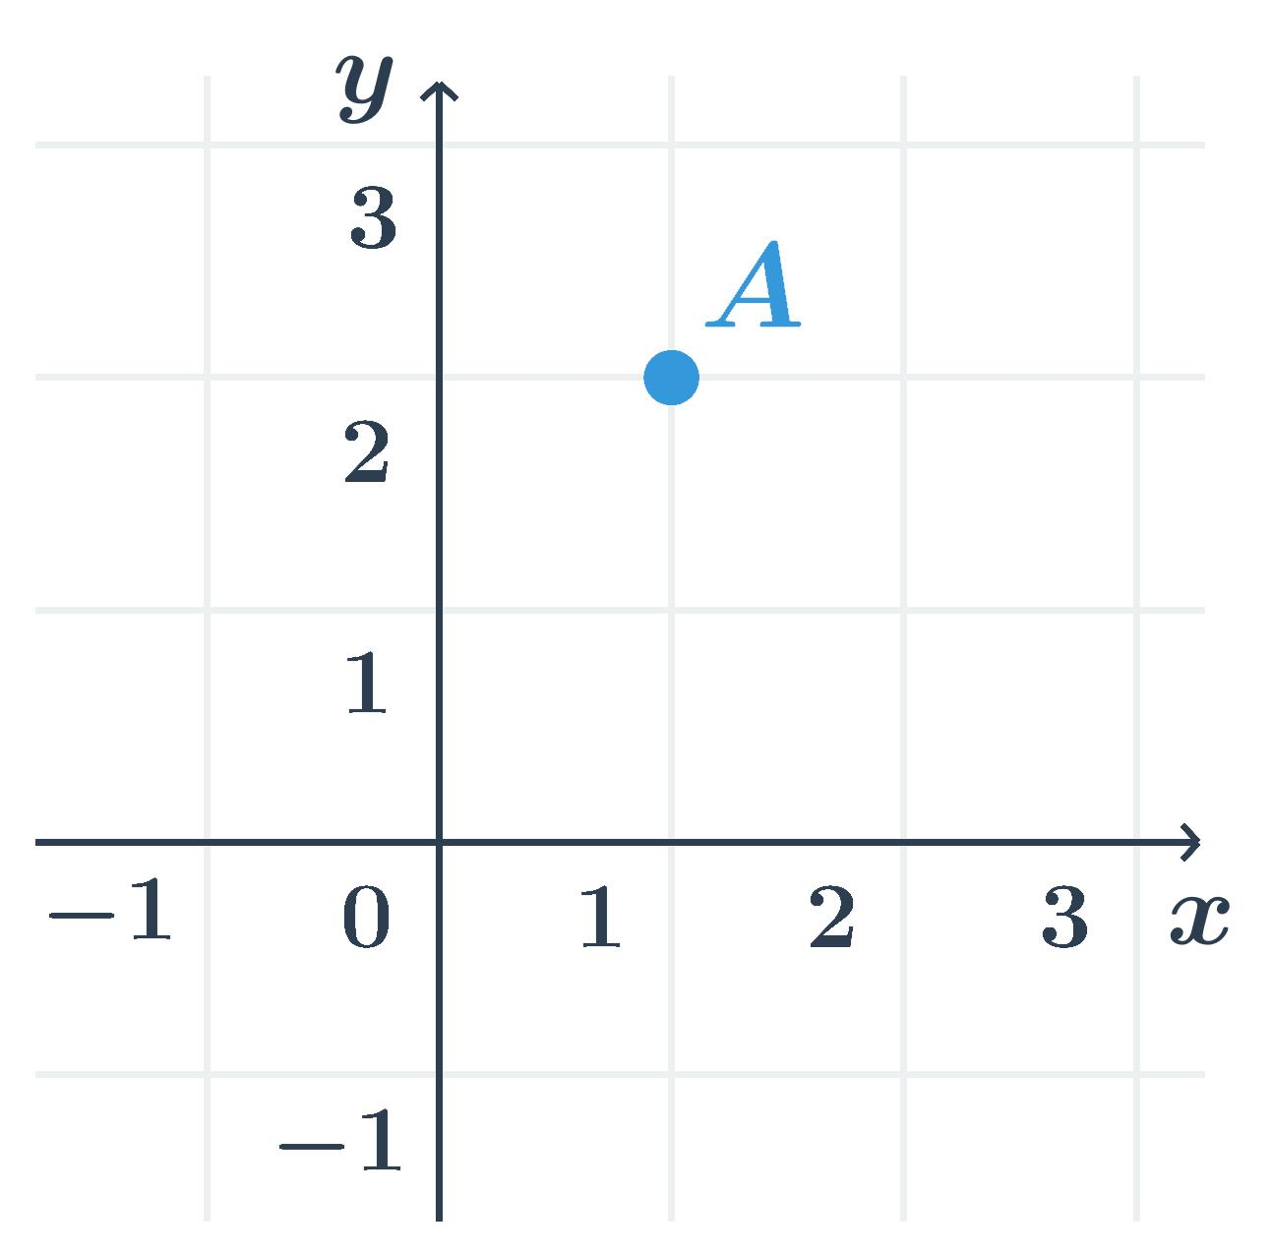
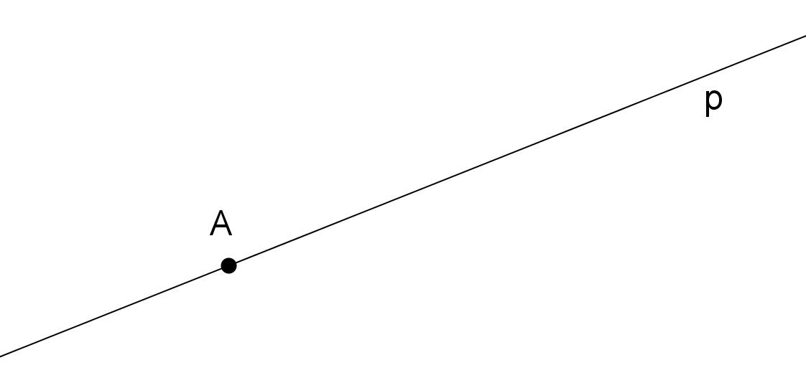
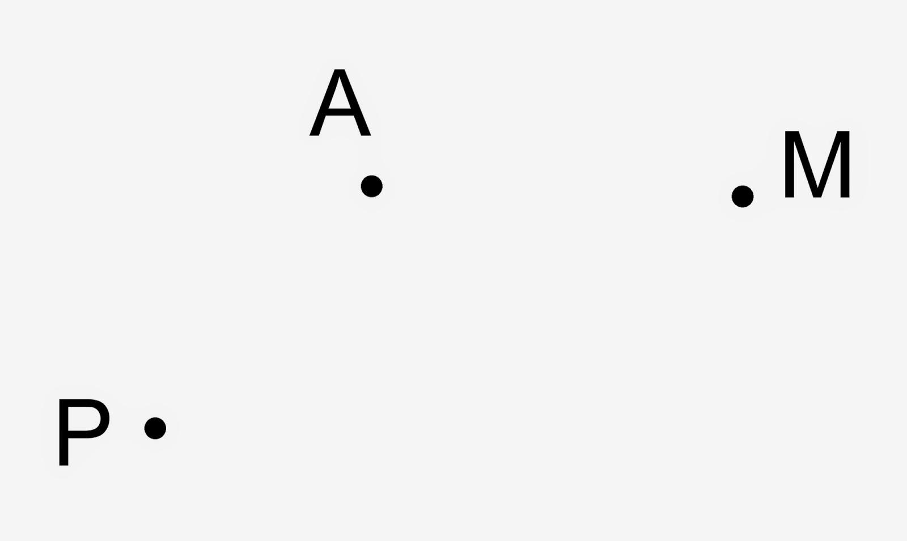
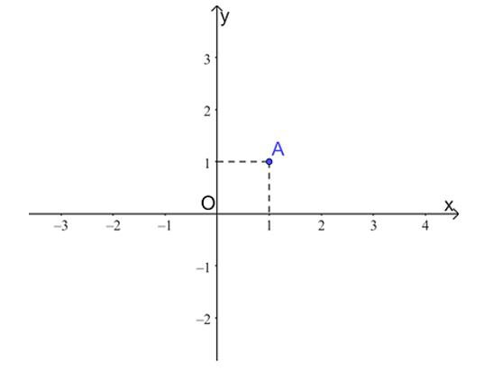
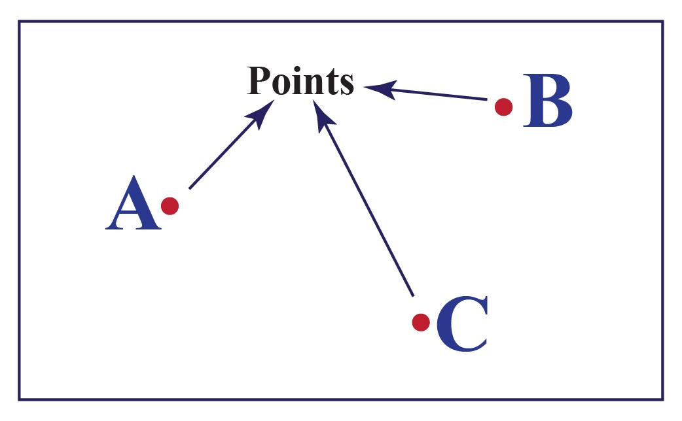

Definition
# Source: AI Source: Provided by: [Data Path: Persons Table -> ID Column: 1, Name_En Column: Motasem Essam] -> From: [ChatGPT] on [7/25/2026]
A Point is the most fundamental concept in plane geometry. It represents an exact location or position in a plane and has no size. A point has no length, width, thickness, area, or volume—it only indicates a position.
Points are the basic building blocks from which all other geometric figures, such as lines, angles, and polygons, are constructed.

Characteristics
# Source: AI Source: Provided by: [Data Path: Persons Table -> ID Column: 1, Name_En Column: Motasem Essam] -> From: [ChatGPT] on [7/25/2026]
A point has the following properties:
- Has no dimensions (zero-dimensional).
- Represents an exact location.
- Cannot be measured.
- Has no shape.
- Has no area or volume.
- Can be identified by a name or coordinates.

Representation
# Source: AI Source: Provided by: [Data Path: Persons Table -> ID Column: 1, Name_En Column: Motasem Essam] -> From: [ChatGPT] on [7/25/2026]
A point is represented by a small dot and labeled with a capital letter.
Examples:
- Point A
- Point B
- Point P
• A

Notation
# Source: AI Source: Provided by: [Data Path: Persons Table -> ID Column: 1, Name_En Column: Motasem Essam] -> From: [ChatGPT] on [7/25/2026]
Points are commonly denoted by uppercase letters:
$$A, B, C, P, Q, R$$

Coordinates
# Source: AI Source: Provided by: [Data Path: Persons Table -> ID Column: 1, Name_En Column: Motasem Essam] -> From: [ChatGPT] on [7/25/2026]
In coordinate geometry, a point is represented by an ordered pair.
Example:
$$A\left(3 , 5\right)$$
where:
- 3 is the x-coordinate.
- 5 is the y-coordinate.

Properties
# Source: AI Source: Provided by: [Data Path: Persons Table -> ID Column: 1, Name_En Column: Motasem Essam] -> From: [ChatGPT] on [7/25/2026]
A point:
- Occupies a unique position.
- Has zero dimensions.
- May lie on a line, curve, or plane.
- May serve as the endpoint of a line segment or ray.
- May represent the intersection of two geometric objects.

Types of Points

1. Interior Point
# Source: AI Source: Provided by: [Data Path: Persons Table -> ID Column: 1, Name_En Column: Motasem Essam] -> From: [ChatGPT] on [7/25/2026]
A point located inside a geometric figure.
Example:
A point inside a triangle.

2. Exterior Point
# Source: AI Source: Provided by: [Data Path: Persons Table -> ID Column: 1, Name_En Column: Motasem Essam] -> From: [ChatGPT] on [7/25/2026]
A point located outside a geometric figure.

3. Boundary Point
# Source: AI Source: Provided by: [Data Path: Persons Table -> ID Column: 1, Name_En Column: Motasem Essam] -> From: [ChatGPT] on [7/25/2026]
A point located on the boundary or edge of a figure.
Example:
A point on the circumference of a circle.

4. Collinear Points
# Source: AI Source: Provided by: [Data Path: Persons Table -> ID Column: 1, Name_En Column: Motasem Essam] -> From: [ChatGPT] on [7/25/2026]
Points lying on the same straight line.
A •────────• B────────• C

5. Non-Collinear Points
# Source: AI Source: Provided by: [Data Path: Persons Table -> ID Column: 1, Name_En Column: Motasem Essam] -> From: [ChatGPT] on [7/25/2026]
Points that do not lie on the same straight line.
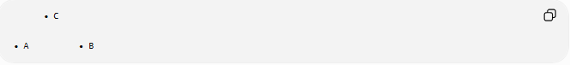
• C

• A • B

6. Coplanar Points
# Source: AI Source: Provided by: [Data Path: Persons Table -> ID Column: 1, Name_En Column: Motasem Essam] -> From: [ChatGPT] on [7/25/2026]
Points lying on the same plane.

7. Coincident Points
# Source: AI Source: Provided by: [Data Path: Persons Table -> ID Column: 1, Name_En Column: Motasem Essam] -> From: [ChatGPT] on [7/25/2026]
Two or more points occupying exactly the same location.

Geometric Relationships
# Source: AI Source: Provided by: [Data Path: Persons Table -> ID Column: 1, Name_En Column: Motasem Essam] -> From: [ChatGPT] on [7/25/2026]
A point can:
- Lie on a line.
- Lie on a curve.
- Lie on a plane.
- Be an endpoint of a segment.
- Be the vertex of an angle.
- Be the center of a circle.
- Be the intersection of two or more lines.

Applications
# Source: AI Source: Provided by: [Data Path: Persons Table -> ID Column: 1, Name_En Column: Motasem Essam] -> From: [ChatGPT] on [7/25/2026]
Points are used in:
- Coordinate geometry
- Engineering drawings
- Computer graphics
- Surveying
- Navigation
- Architecture
- Mapping
- CAD (Computer-Aided Design)
- Robotics

Advantages
# Source: AI Source: Provided by: [Data Path: Persons Table -> ID Column: 1, Name_En Column: Motasem Essam] -> From: [ChatGPT] on [7/25/2026]
Using points allows us to:
- Specify exact locations.
- Build geometric figures.
- Define coordinates.
- Describe geometric relationships.
- Support mathematical proofs.

Limitations
# Source: AI Source: Provided by: [Data Path: Persons Table -> ID Column: 1, Name_En Column: Motasem Essam] -> From: [ChatGPT] on [7/25/2026]
A point:
- Has no measurable size.
- Cannot exist physically as a perfect mathematical object.
- Is an idealized concept.

Related Concepts
# Source: AI Source: Provided by: [Data Path: Persons Table -> ID Column: 1, Name_En Column: Motasem Essam] -> From: [ChatGPT] on [7/25/2026]
A point is closely related to:
- Line
- Line Segment
- Ray
- Plane
- Coordinate System
- Distance
- Midpoint
- Vertex

Comparison
# Source: AI Source: Provided by: [Data Path: Persons Table -> ID Column: 1, Name_En Column: Motasem Essam] -> From: [ChatGPT] on [7/25/2026]
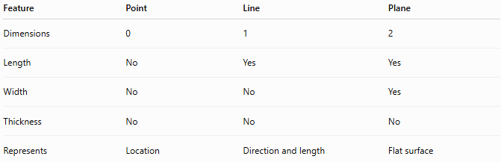
Feature | Point | Line | Plane
Dimensions | 0 | 1 | 2
Length | No | Yes | Yes
Width | No | No | Yes
Thickness | No | No | No
Represents | Location | Direction and length | Flat surface

Key Points
# Source: AI Source: Provided by: [Data Path: Persons Table -> ID Column: 1, Name_En Column: Motasem Essam] -> From: [ChatGPT] on [7/25/2026]
- A Point is a zero-dimensional geometric object.
- It represents an exact location.
- It has no length, width, area, or volume.
- Points are named using uppercase letters.
- All geometric figures are built from points.

Conclusion
# Source: AI Source: Provided by: [Data Path: Persons Table -> ID Column: 1, Name_En Column: Motasem Essam] -> From: [ChatGPT] on [7/25/2026]
A Point is the most basic element in plane geometry, representing an exact position without any dimensions. Although it has no measurable size, it serves as the foundation for constructing and describing all other geometric objects, including lines, angles, polygons, and circles. Points are indispensable in geometry, coordinate systems, engineering, surveying, architecture, mapping, and computer graphics, where precise locations are essential.

